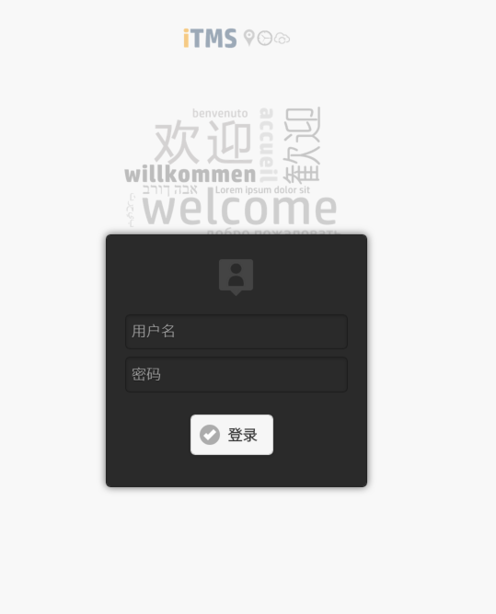

使用桌面版的login登录service

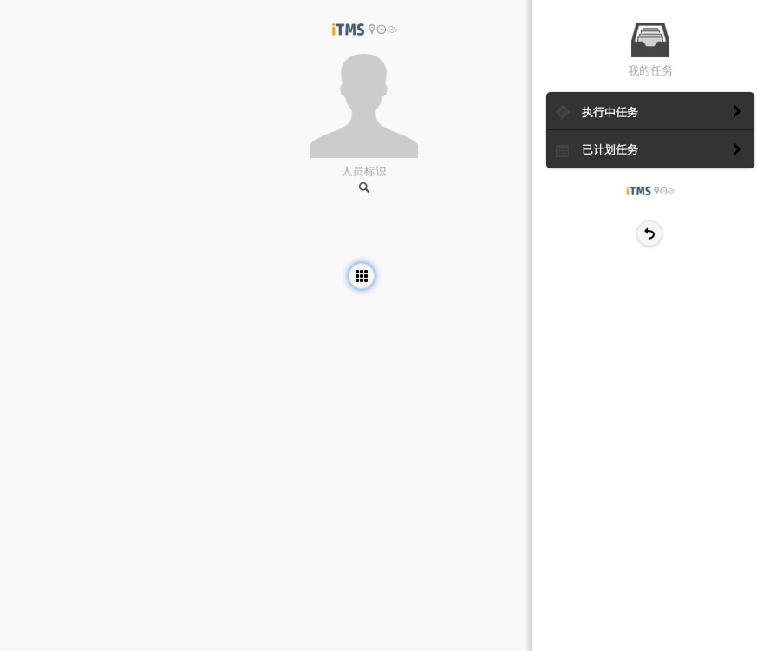

U的任务

O的任务

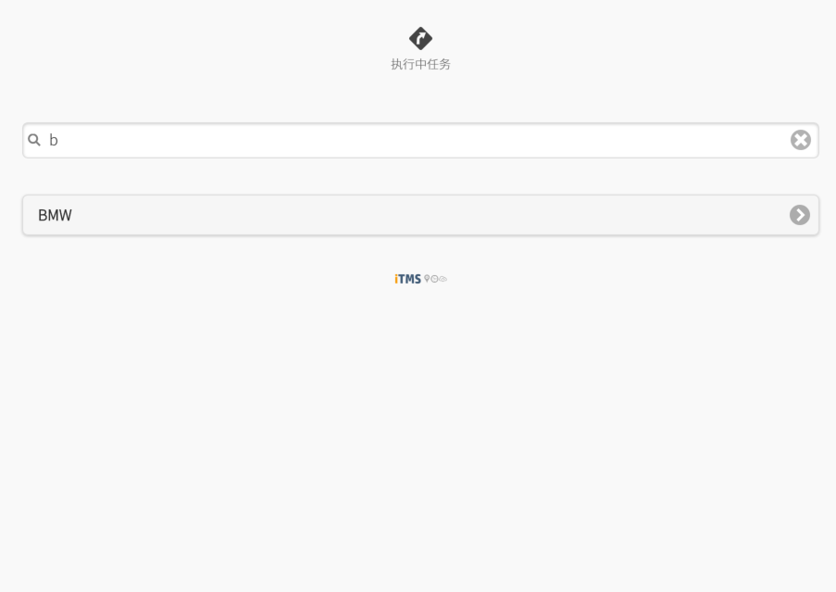

目前请使用固定值KRCC

所使用的webservice

<http://211.144.85.15:8080/itms/rest/EO/EOQuickSearchMobile>

SerType=AND

statusGroup = O或者U

project = autocomplete传入的值，目前为KRCC

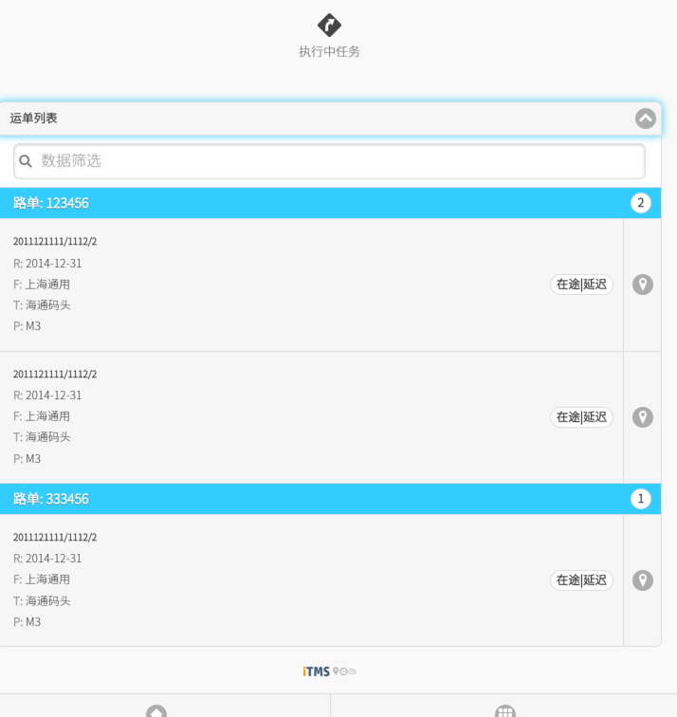

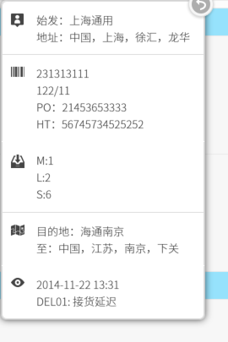

recCustomerDesc

depCustomerDesc

CustomerOrder1

CustomerOrder2

关于地图

地图中需要显示以下几类

1. 车辆当前位置信息
2. 订单事件信息位置
3. 订单轨迹信息
4. 车辆当前位置信息，使用webservice：<http://211.144.85.15:8080/itms/rest/EO/EOItemLocationSearch>可以获取到。这个service会返回一个坐标点的信息。

输入值S[]=S1,E[]=E1 固定，

注意，因为我们用的是google地图，所以需要使用返回值中的谷歌坐标。

"googleLatitude": "31.250544162326",

"googleLongitude": "121.46457383898",

返回值中下面标注黄色的信息需要显示到地图的infoWindow中

[

{

"eo": 81,

"erID": 325,

"erITN": 2,

"startEventType": "NORM",

"startEventCode": "EVTNA3",

"endEventType": "NORM",

"endEventCode": "EVTNA4",

"location": [

{

"id": 902,

"username": "135",

"mobile": null,

"type": null,

"resID": null,

"speed": "0.0",

"timestamp": "2014-12-07 22:19:45",

"mobileTimestamp": "2014-12-07 22:19:00",

"bearing": null,

"latitude": "31.252435",

"longitude": "121.460002",

"googleLatitude": "31.250544162326",

"googleLongitude": "121.46457383898",

"baiduLatitude": "31.256648671935",

"baiduLongitude": "121.47105676255",

"errorCode": "0"

}

],

"errorMessage": "OK"

}

]

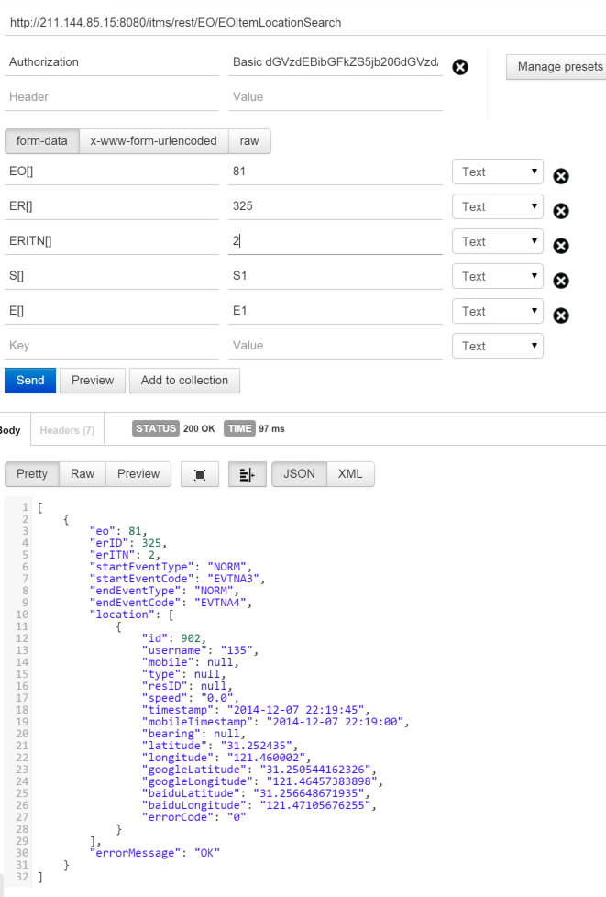

1. 订单事件坐标调用以下服务获取

<http://211.144.85.15:8080/itms/rest/EO/EOItemEventLocationSearch>

他会返回一组位置信息。每一个位置信息都要以一个pin反应在地图上。返回值中黄色部分需要展示在infowindow中

[

{

"eo": 81,

"er": 325,

"erITN": 2,

"events": [

{

"eventID": 406,

"eventDateTime": "2014-12-07 22:03:26",

"createUser": 10000,

"eventType": "NORM",

"eventCode": "EVTNA3",

"eventListener1": "I18",

"eventListener2": "I2",

"eventListener3": "I3",

"eventListener4": "I4",

"memo": "",

"eventStatus": null,

"resEventID": null,

"latitude": "121.460002",

"longitude": "31.252435",

"googleLatitude": null,

"googleLongitude": null,

"baiduLatitude": null,

"baiduLongitude": null,

"eo": 81,

"erid": 325,

"eritn": 2

},

{

"eventID": 407,

"eventDateTime": "2014-12-07 22:12:37",

"createUser": 10000,

"eventType": "NORM",

"eventCode": "EVTNA3",

"eventListener1": "I18",

"eventListener2": "I2",

"eventListener3": "I3",

"eventListener4": "I4",

"memo": "",

"eventStatus": null,

"resEventID": null,

"latitude": "0",

"longitude": "0",

"googleLatitude": null,

"googleLongitude": null,

"baiduLatitude": null,

"baiduLongitude": null,

"eo": 81,

"erid": 325,

"eritn": 2

},

{

"eventID": 408,

"eventDateTime": "2014-12-07 22:13:39",

"createUser": 10000,

"eventType": "NORM",

"eventCode": "EVTNA3",

"eventListener1": "I18",

"eventListener2": "I2",

"eventListener3": "I3",

"eventListener4": "I4",

"memo": "",

"eventStatus": null,

"resEventID": null,

"latitude": "121.460002",

"longitude": "31.252435",

"googleLatitude": null,

"googleLongitude": null,

"baiduLatitude": null,

"baiduLongitude": null,

"eo": 81,

"erid": 325,

"eritn": 2

},

{

"eventID": 409,

"eventDateTime": "2014-12-07 22:18:24",

"createUser": 10000,

"eventType": "NORM",

"eventCode": "EVTNA3",

"eventListener1": "I18",

"eventListener2": "I2",

"eventListener3": "I3",

"eventListener4": "I4",

"memo": "",

"eventStatus": null,

"resEventID": null,

"latitude": "31.252435",

"longitude": "121.460002",

"googleLatitude": "31.250544162326",

"googleLongitude": "121.46457383898",

"baiduLatitude": "31.256648671935",

"baiduLongitude": "121.47105676255",

"eo": 81,

"erid": 325,

"eritn": 2

}

],

"errorMessage": "OK"

}

]

1. 轨迹信息调用以service

<http://211.144.85.15:8080/itms/rest/EO/EOItemRoutePathSearch>

输入参数S[]=S1,E[]=E1固定

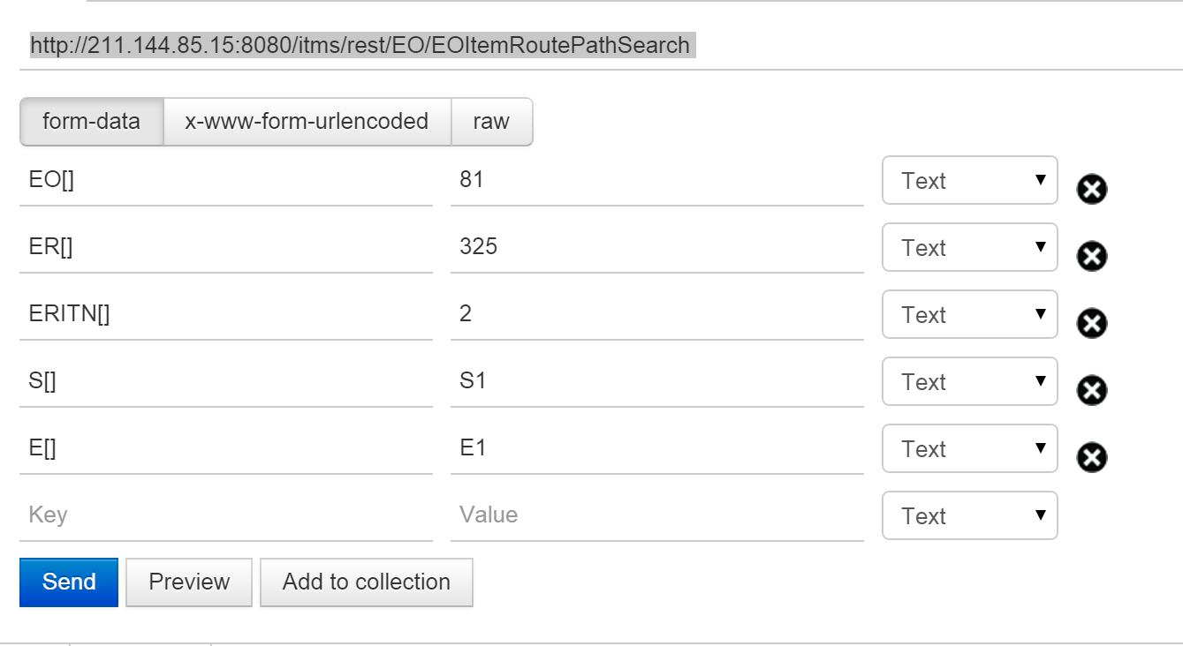

返回值也是一组位置数据，需要将这些数据按照mobileTimestamp时间进行排序并且使用，googleLatitue，googleLongitue进行多段折线绘制

[

{

"eo": 81,

"erID": 325,

"erITN": 2,

"startEventType": "NORM",

"startEventCode": "EVTNA3",

"endEventType": "NORM",

"endEventCode": "EVTNA4",

"location": [

{

"id": 898,

"username": "135",

"mobile": null,

"type": null,

"resID": null,

"speed": "0.0",

"timestamp": "2014-12-07 22:13:18",

"mobileTimestamp": "2014-12-07 22:12:00",

"bearing": null,

"latitude": "31.252435",

"longitude": "121.460002",

"googleLatitude": "31.250544162326",

"googleLongitude": "121.46457383898",

"baiduLatitude": "31.256648671935",

"baiduLongitude": "121.47105676255",

"errorCode": "0"

},

{

"id": 899,

"username": "135",

"mobile": null,

"type": null,

"resID": null,

"speed": "0.0",

"timestamp": "2014-12-07 22:14:31",

"mobileTimestamp": "2014-12-07 22:13:00",

"bearing": null,

"latitude": "31.252435",

"longitude": "121.460002",

"googleLatitude": "31.251544162326",

"googleLongitude": "121.49457383898",

"baiduLatitude": "31.256648671935",

"baiduLongitude": "121.47105676255",

"errorCode": "0"

},

{

"id": 900,

"username": "135",

"mobile": null,

"type": null,

"resID": null,

"speed": "0.0",

"timestamp": "2014-12-07 22:18:04",

"mobileTimestamp": "2014-12-07 22:17:00",

"bearing": null,

"latitude": "31.252435",

"longitude": "121.460002",

"googleLatitude": "31.253544162326",

"googleLongitude": "121.48457383898",

"baiduLatitude": "31.256648671935",

"baiduLongitude": "121.47105676255",

"errorCode": "0"

},

{

"id": 901,

"username": "135",

"mobile": null,

"type": null,

"resID": null,

"speed": "0.0",

"timestamp": "2014-12-07 22:18:45",

"mobileTimestamp": "2014-12-07 22:18:00",

"bearing": null,

"latitude": "31.252435",

"longitude": "121.460002",

"googleLatitude": "31.220544162326",

"googleLongitude": "121.4857383898",

"baiduLatitude": "31.256648671935",

"baiduLongitude": "121.47105676255",

"errorCode": "0"

},

{

"id": 902,

"username": "135",

"mobile": null,

"type": null,

"resID": null,

"speed": "0.0",

"timestamp": "2014-12-07 22:19:45",

"mobileTimestamp": "2014-12-07 22:19:00",

"bearing": null,

"latitude": "31.252435",

"longitude": "121.460002",

"googleLatitude": "31.260544162326",

"googleLongitude": "121.48457383898",

"baiduLatitude": "31.256648671935",

"baiduLongitude": "121.47105676255",

"errorCode": "0"

}

],

"errorMessage": "OK"

}

]